**ADDENDUM**

2022 Program-Level Assessment

Annual Assessment | Rubrics, Results, Intentions

Submitted June 30, 2023

Figure 1 Coun 5050 HGD

023

Results:

The assessment outcomes for the Coun 5050 Human Growth and Development course in 2021 revealed that 62% of students exceeded the program-level criteria, indicating a solid understanding of the course content. However, the 2022 assessment of 52 students in the showed a similar pattern, with 25% of students not meeting the criteria in the relevance and implications section. The mean score for this section was 1.8, indicating a need for improvement. This suggests that students faced challenges in applying the course theory and models to real-world scenarios for analysis in their "Grow Your Own Human" papers. However, the overall content knowledge score was promising, with 75% overall above the 2.0 criteria at 52% exceeding and 23% meeting the criteria.

Intentions:

While there has been some improvement in connecting the course content to real-world applications, the results indicate the need for further enhancement in the relevance and implications section. Our intention is to address this gap by implementing strategies that foster a deeper understanding and application of the course material. We will provide additional support and resources to help students bridge the theory-to-practice gap and strengthen their ability to analyze human growth and development in real-life contexts.

Proposed changes may include incorporating more practical exercises and case studies, offering targeted guidance and feedback during the assignment process, and providing opportunities for discussions and reflection on the relevance and implications of the course concepts.

By focusing on these areas and encouraging active student engagement, we aim to improve the level of connection between theory and application, resulting in a higher percentage of students meeting the criteria in the relevance and implications section.

Figure 2 Coun 5850 Research Proposal Paper

Results:

The program assessment outcomes for the *Coun 5850 Research* course indicate a transitional period in the previous year, 2021, due to the implementation of Tevera, the data management system, and the lingering impact of the COVID-19 pandemic. These factors contributed to low completion rates for the course, potentially influenced by the high utilization of adjunct instructors. Furthermore, faculty members were still learning the Tevera system, resulting in unusable data sets. However, the outlook for 2022 is promising.

Intentions:

In the assessment of Coun 5850 Research course, a total of 35 students were evaluated. The results show that only 3 students, representing 9% of the cohort, scored below the "meets" criteria for the writing assessment, specifically in the methodology section of their papers. Historically, this section has been challenging for many students. Encouragingly, 66% of the students met the criteria, while 26% exceeded expectations in the same key performance indicator of methodology. These numbers indicate that students are performing well and as expected.

Based on the assessment results, no changes to the curriculum or its presentation are warranted at this time. Instead, faculty will be encouraged to continue their current efforts in teaching the Coun 5850 Research course with a focus on covering learning objectives and clear consistent documentation.

Results:

The program assessment outcomes for the Coun 5800 Professional Orientation and Ethics course in 2022 provide valuable insights into student performance. To contextualize these results, let's briefly discuss the findings from 2021. In that year, mastery of the course material was evidenced by 3.0 scores for content knowledge and responsiveness on the final writing project.

In 2022, the assessment results revealed that out of the 23 students assessed, 17% scored at the exceed criteria for responsiveness to the assignment, while 22% scored at the exceed criteria for content knowledge. Additionally, 48% of the students scored at the meets criteria for responsiveness, 65% for content knowledge, and 43% for presentation style.

However, it is important to note that some areas require improvement. Scores of 35%, 13%, 43%, and 87% were obtained for responsiveness to assignments, content knowledge, presentation style, and writing skills, respectively, indicating that students minimally meet the criteria. Furthermore, there were areas where students did not meet the criteria at rates of 13% for presentation style and 9% for writing skills.

Intentions:

The Coun 5800 Professional Orientation and Ethics course utilizes the Tevera data management system as a tool to improve the nuances of the ethics final writing project. The intent of this project is to assess potential real-world ethical dilemmas and gauge students' ability to apply key ethical model principles in a manner that positively impacts the counseling community members.

The 2022 results highlight a need for support in presentation style and writing skills. While these criteria may appear minimal on the surface, they are essential in conveying conceptual ideas effectively to the general public and ensuring the safety and confidentiality of potential clients.

Moving forward, the faculty should consider providing additional guidance and resources to help students enhance their presentation style and writing skills. By addressing these areas, students will be better equipped to effectively communicate ethical concepts and uphold professional standards within the counseling community.

Results:

The program assessment outcomes for the Coun 5220 Assessment course in 2022 provide insight into student performance. To provide context, let's discuss the results from 2021. In that year, scores for the Coun 5220 Assessment course consistently exceeded 2.82 on a Likert scale of 0 to 3.0, with the mean ranging from 2.82 to 3.00. These scores indicated that the course was performing well and as expected.

In the 2022 course outcome review for Coun 5220 Assessment, a total of 30 students were evaluated. The scores reflected a mean of 2.43 or above for the meets and exceeds criteria. While this mean is 0.39 lower than the 2021 scores, it still falls within an acceptable range. Based on these results, no immediate curriculum changes are warranted.

However, it is important for the assessment team to monitor any further downward movement in the criteria scores. If there is a consistent decline, it may indicate a need for adjustments in the course content or instructional methods. Continuing to track the performance of students in subsequent assessments will provide valuable insights into the effectiveness of the Coun 5220 Assessment course and ensure its ongoing quality.

Figure 3 Coun 5600 GROUP COURSE

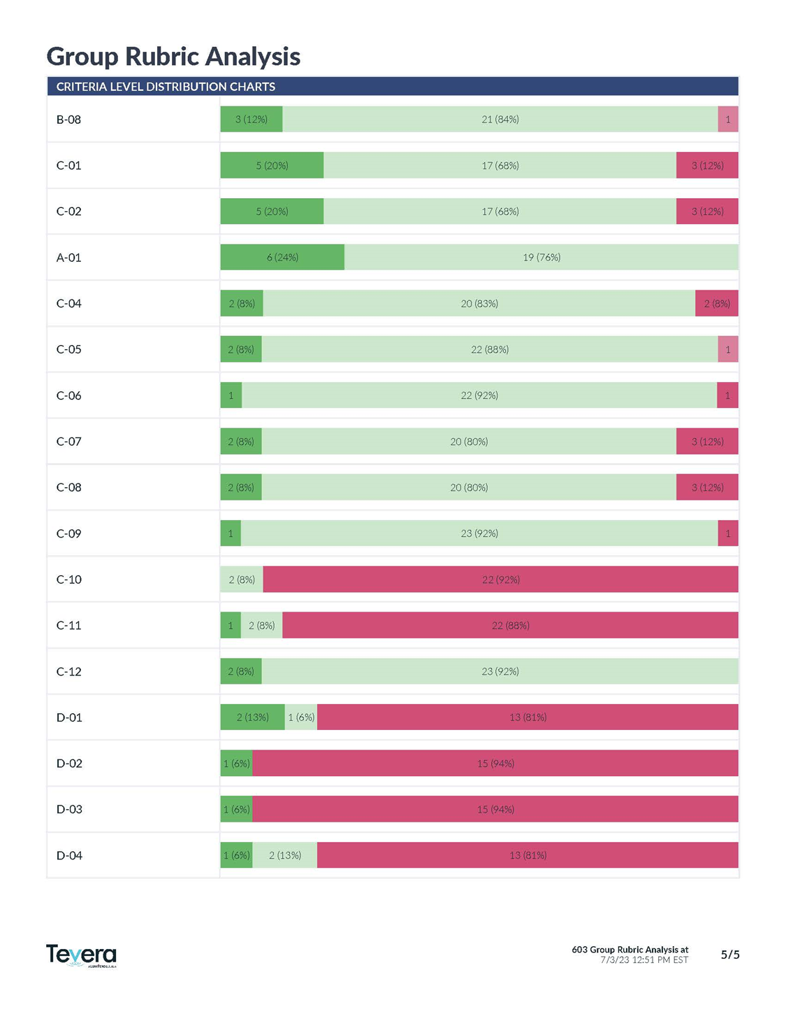

Results:

The assessment review for the Coun 5600 Techniques of Group course in 2022, which included 25 students, indicates that the majority of students scored either "meets the criteria" or "exceeds the criteria" in key areas such as attitudes, personality traits, appropriate behaviors for counseling students, learning attitudes and behaviors, and basic counseling skills. These results are consistent with previous years' findings.

However, it's important to acknowledge that the rubric reflects a mean range of 0 to 0.53 due to the number of "no opportunity to observe" and "not applicable" scores. Upon closer review of the assessment scores for the Coun 5600 Techniques of Group course, it is important to note that the significant decrease in the mean was primarily influenced by the criterion in sections F (openness to clinical supervision) and G (school counseling). It is worth noting that these criteria may not be as relevant or essential to this particular course at this time in the program. This suggests a need to make adjustments to the scoring system, particularly for beginning and mid-level courses like Group and other foundational courses, to address this issue. We recognize that the scoring of the Professional Skills Evaluations (PSE) is subjective, as it relies heavily on faculty or adjunct instructor interpretation.

In 2021, the assessment of 19 students in the Coun 5600 Group Dynamics course revealed scores consistently at or above 2.0 on a Likert scale ranging from 0 to 3.0, with a mean of 2.0166. The PSE reflected that students met or exceeded the criteria for program expectations, particularly in sections A. Aptitudes & behaviors and B. Learning attitudes & behaviors. Other sections received scores of "n/a" or "no opportunity to observe."

Intentions:

Moving forward, our intentions include discussing modifications to the PSE scoring options to better support developmental courses and address the issue of scoring "n/a" or "no opportunity to observe." We aim to ensure that the scoring system accurately reflects students' progress and performance in these courses. This may involve refining the criteria or providing clearer guidelines for evaluating students' skills and abilities.

By making these adjustments, we aim to enhance the assessment process and provide more meaningful feedback to students. We are committed to continuously improving our instructional practices and assessment methods to better support student learning and development.

Results:

The assessment review for the Coun 5100 Social Cultural Foundations (SCF) course in 2021 indicates that scores were consistently above 2.0, demonstrating the development of awareness, knowledge, and skills related to key concepts and ideas of the course. This includes topics such as cultural humility and the impact of racism at a strategic level. Scores of 2.44 on a Likert scale of 0-3 reflect an above-average demonstration of understanding of these content areas. The Professional Skills Evaluation (PSE) documented basic counseling skills that demonstrated awareness of belief systems, values, biases, racial identity, and respect for cultural differences. Overall, the course effectively delivered the intended content learning outcomes.

In the 2022 assessment review, which included 26 students, similar results were observed, with the majority of students scoring 2.0 or above on the Likert scale. However, it's important to note that certain criteria under sections E (integration of theory and practice) and F (openness to clinical supervision) did not apply at this stage, as this is the second course in the program. These criteria, therefore, contributed to a significant drop in the mean scores.

Intentions:

Based on these assessment results, our intentions include reviewing the criteria under sections E and F to better align them with the progression of the program. We will ensure that the assessment focuses on the relevant skills and knowledge for students at this stage of their learning journey. By making these adjustments, we aim to provide a more accurate reflection of student performance and maintain consistency in the assessment process.

Furthermore, we will continue to emphasize the importance of integrating theory and practice and being open to clinical supervision as students’ progress through the program. We will explore ways to incorporate these aspects more effectively in subsequent courses to provide a comprehensive and well-rounded learning experience.

Results:

The program assessment outcomes for the Coun 6100 and 6200 Practicum courses, which serve as introductory field experience courses, provide insights into student performance and progress. These courses aim to give students an overview of what it's like to be a counselor. Let's discuss the results from the 2021 and 2022 assessments.

In the 2021 assessment review for Coun 6100, scores ranged from 1.38 to 2.39 on a Likert scale of 0 to 3. These scores reflect typical beginner training ratings, as many students have initial apprehensions about field experience sites. Historically, these scores improve slightly by Coun 6200. While the average score was around 2.0, with a high of 2.39, scores lower than 2.0 were noted in areas such as using therapeutic silence, inferring unstated meaning, case conceptualization, and understanding and usage of the diagnostic manual. Addressing these areas is crucial, and historically, they tend to improve with each field experience course.

For Coun 6200, scores ranged from 1.75 to 2.42 on the Likert scale in the 2021 assessment review. As a beginner field experience course, there is ample room for improvement in the application of skills. Scores typically fell around 2.0, with a high of 2.42. Skills such as case conceptualization, data assessment, and diagnostics were areas that scored below 2.0, indicating areas for further development.

In the 2022 assessment review, 24 students were scored. The majority of key performance indicators (KPIs) consistently met the criteria, with scores such as C-03 at 2.29, A-02 at 2.23, and D-01 at 2.33. Scores below 2.0 were mainly observed in the "did not have the opportunity to observe" portion of the Professional Skills Evaluation (PSE).

It is important to acknowledge the transitional nature of these beginning mental health field experience courses. Students experience a learning curve as they grow and develop their clinical skills with weekly supervision from both faculty and site supervisors.

Intentions:

The intention of the Coun 6100 and 6200 Practicum courses is to allow students to cultivate and enhance their clinical skills through real-world experiences. Weekly supervision provided by faculty and site supervisors plays a vital role in guiding and supporting students' growth in these courses. The assessment outcomes indicate that students are progressing and meeting the majority of the KPIs.

Moving forward, it is crucial to continue addressing the areas where scores fall below 2.0, such as case conceptualization, data assessment, and diagnostics. By providing targeted support and guidance, students can further develop these complex skills. Ongoing monitoring and support will contribute to the continued improvement of students' clinical abilities in the field experience courses.